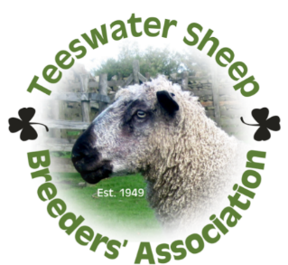
TEESWATER SHEEP BREEDERS’ ASSOCIATION LTD
ANNUAL SALE – 5th OCTOBER 2023
ENTRY FORM
Leyburn Auction Mart

Name:________________________________Address:________________________________________________________________________________________________________
Phone:________________________________Mobile:_______________________________
Email:________________________________

Teeswater Flock Number:_____________
Teeswater Flock Name:_______________
UK Number:UK_____________________
Holding Number:____/______/_________
Please delete accordingly: MV / Non-MV_

Entries must be from a current Teeswater Association member

Class 1 – Registered Teeswater Aged Ram

Registration No. | Sire Reg. No | Dam Reg No | Breeder if not Seller

Class 2 – Registered Teeswater Shearling Ram

Registration No | Sire Reg. No. | Dam Reg. No | Breeder if not Seller

Class 3 – Registered Teeswater Ram Lamb

Registration No | Sire Reg. No. | Dam Reg. No | Breeder if not Seller
Female Entries are listed overleaf.

Class 4 – Registered Teeswater Female Ewe
Registration No | Sire Reg. No. | Dam Reg. No | Breeder if not Seller
Class 5 – Registered Teeswater Female Shearling
Registration No | Sire Reg. No. | Dam Reg. No | Breeder if not Seller
Class 6 – Registered Teeswater Gimmer Lamb
Registration No | Sire Reg. No. | Dam Reg. No | Breeder if not Seller
Please note all sheep must arrive at the market prior to 9.45am where they will be inspected
All animals to be sold must be registered and of good Teeswater type as well as conforming to the breed points that are stated in the current flock book.
Please return your entry form by Monday, 18th September 2023 to:
Leyburn Auction Mart
Richmond Road
Leyburn, North Yorkshire
DL8 5DP
01969 623167
leyburn@auctionmarts.com
GENERAL DATA PROTECTION REGULATION (GDPR) – Privacy Policy and declaration for forms.
DECLARATION:
I understand the following:
The Teeswater Sheep Breeders’ Association is known as a “data controller” for the purpose of the General Data Protection Regulation (GDPR) 2018. By proceeding to use our service you agree that we may process the personal data that we collect from you in accordance with our Data Protection Policy.
The information we hold about you is your name, address, telephone & mobile numbers and in some cases your email address. We have your UK Flock number, your Holding number and any sheep that you have requested are transferred to your flock or bred by yourself. We do not supply or sell this data to any other organisation for gain. Our pedigree system is operated under the Grassroots system. Our system is backed up onto a hard disc and also paper copies are securely kept. We hold this information for administration purposes and we may use your details when promoting your sheep/the breed if required and for publication in our annual flock book. Please address any questions, comments and requests to info@teeswatersheep.co.uk

Signature: ........................................................ Date: ..................................
Details of the Leyburn GDPR policy can be obtained from their website or by contacting the Mart.

